* Instructions for adding scenes
  + First hold down the program button for three seconds
  + Second click the fixture button for the fixture you want (example Fixture 1)
  + Then set the light how you want it using the different channels
  + Continue this process for the other fixtures
  + Then click rec
  + Then click the scene number (example 1)

Important RGB colors

1. Red = 255,0,0
2. Green = 0,255,0
3. Blue = 0,0,255
4. White = 255,255,255
5. Orange = 255, 128,0
6. Yellow = 255,255,0
7. cyan = 0,255,255
8. purple = 128,0,255
9. magenta = 255,0,255
10. Georgia tech gold = 179,163,105
11. Gold I used = 218,165,32
12. Georgia tech blue = 0,38,58
13. Kappa Sigma Red = 191, 13, 62
14. Kappa Sigma Green = 201,151,0

* Fixture 1 (Proline ThinTri 64)
  + DMX set as Channel **1**
  + 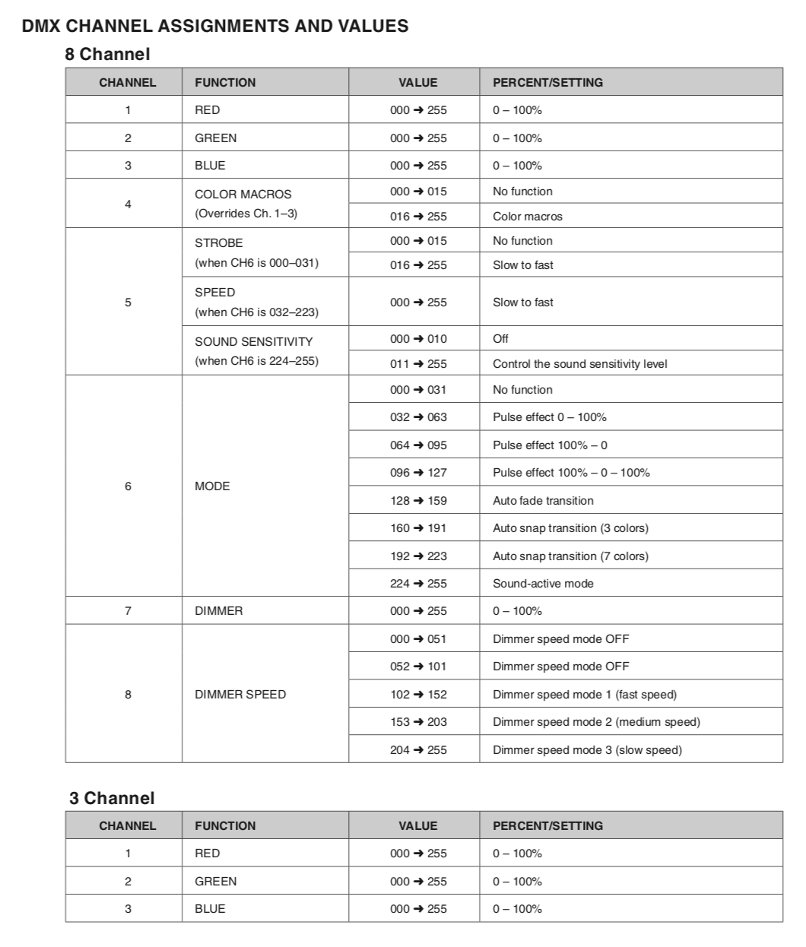
  + Rule of thumb pick the RGB you want
  + Set 5 to 0 unless you have white then you can add strobe
  + Set 6 to 0 unless you want to experiment
  + Set 7 to 255
  + Set 8 to 0
* Fixture 2 (Intimidator Spot Duo) and Fixture 3 because it has 20 channels
  + DMX set as Channel **17**
* Fixture 4 (Proline ThinTri 64)
  + DMX set as Channel **49**
* Fixture 5 (Chauvet mini Kinta IRC)
  + DMX set as Channel **65**
* Fixture 6 (Proline ThinTri 64)
  + DMX set as Channel **81**
* Fixture 7 (Chauvet Scorpion Storm RGB)
  + DMX set as Channel **97**
* Fixture 8 (Proline ThinTri 64)
  + DMX set as Channel **113**
* Fixture 9 (Chauvet mini Kinta IRC)
  + DMX set as Channel **129**

1. Bank 1
   1. Scene 1
   2. Scene 2
   3. Scene 3
   4. Scene 4
   5. Scene 5
   6. Scene 6
   7. Scene 7
   8. Scene 8
2. Bank 2

Chases (Chase takes scenes and adds them together to create a cool effect)

* <https://www.youtube.com/watch?v=nVbVl4s_pQ4>
* Chase 1

Controlling with audio

<https://www.youtube.com/watch?v=TlQPGW-gHGE>

Chase 1

Chase 2

Chase 3

Chase 4

Chase 5

Chase 6